Health & Hygiene
Dr N.Saroja
Health Supervisor
TSWRAFPDCW, Bhongir
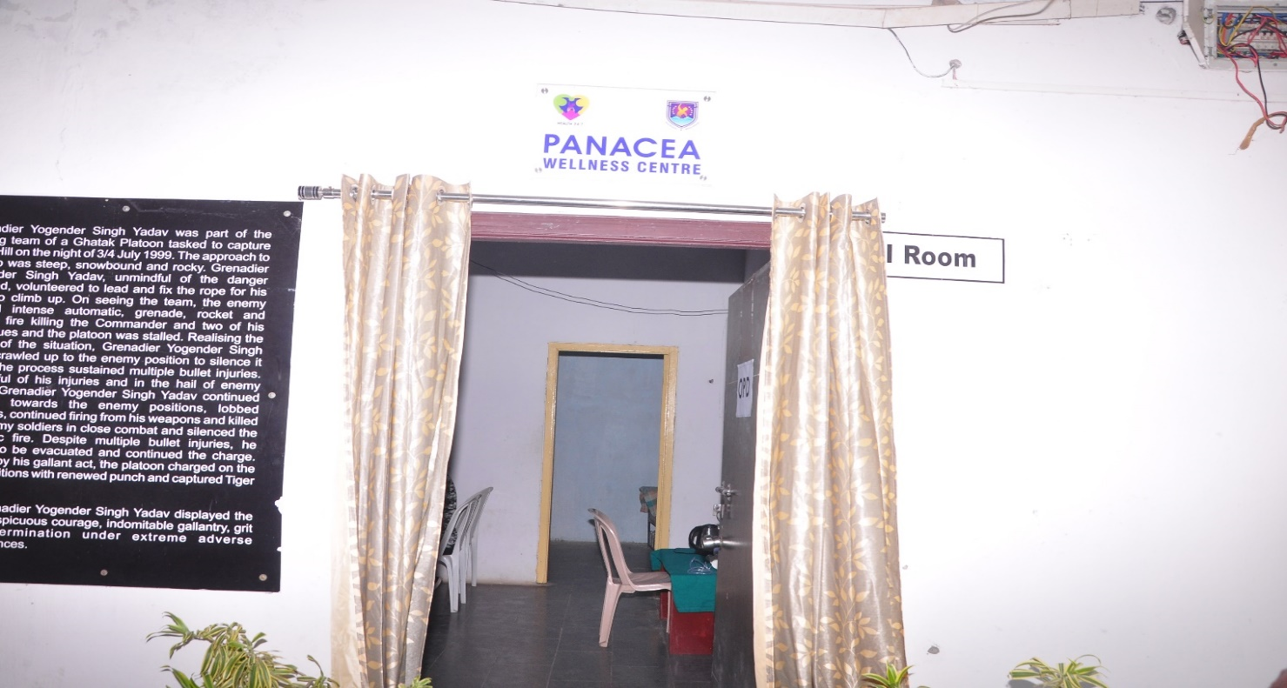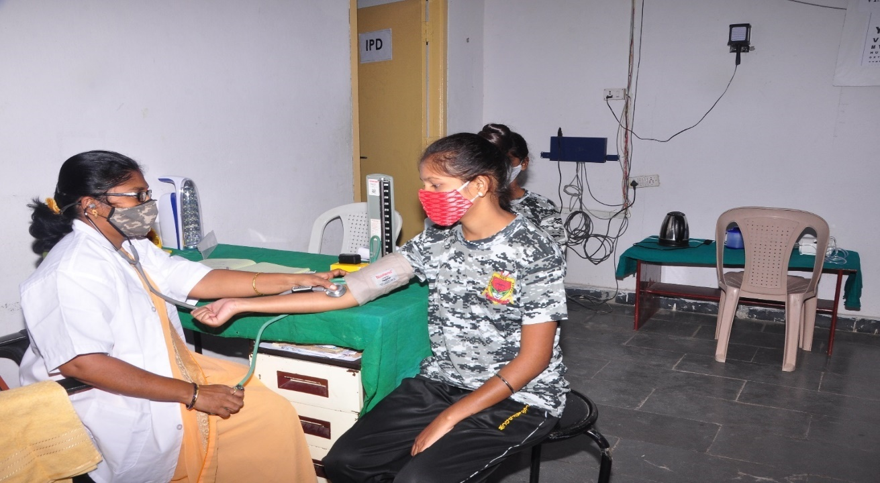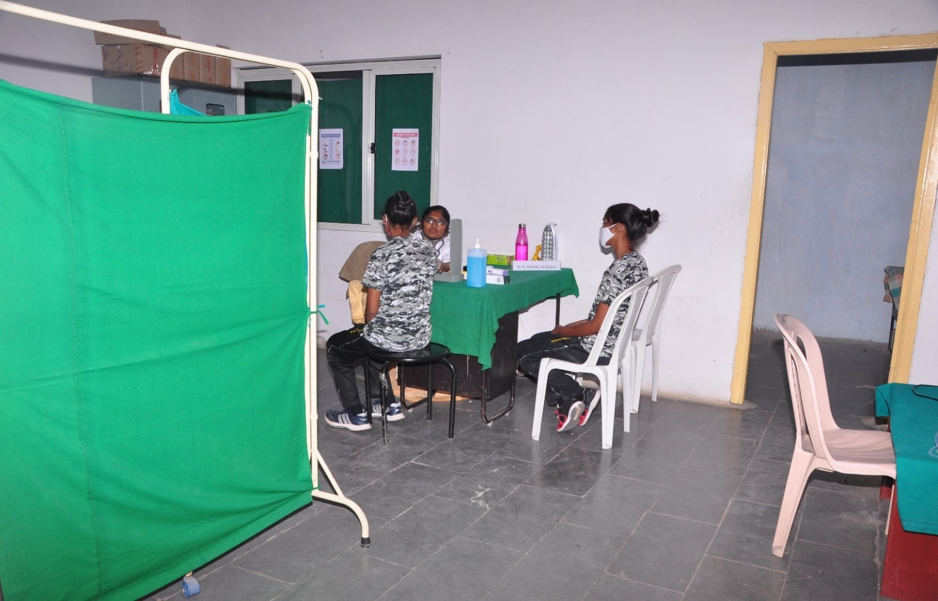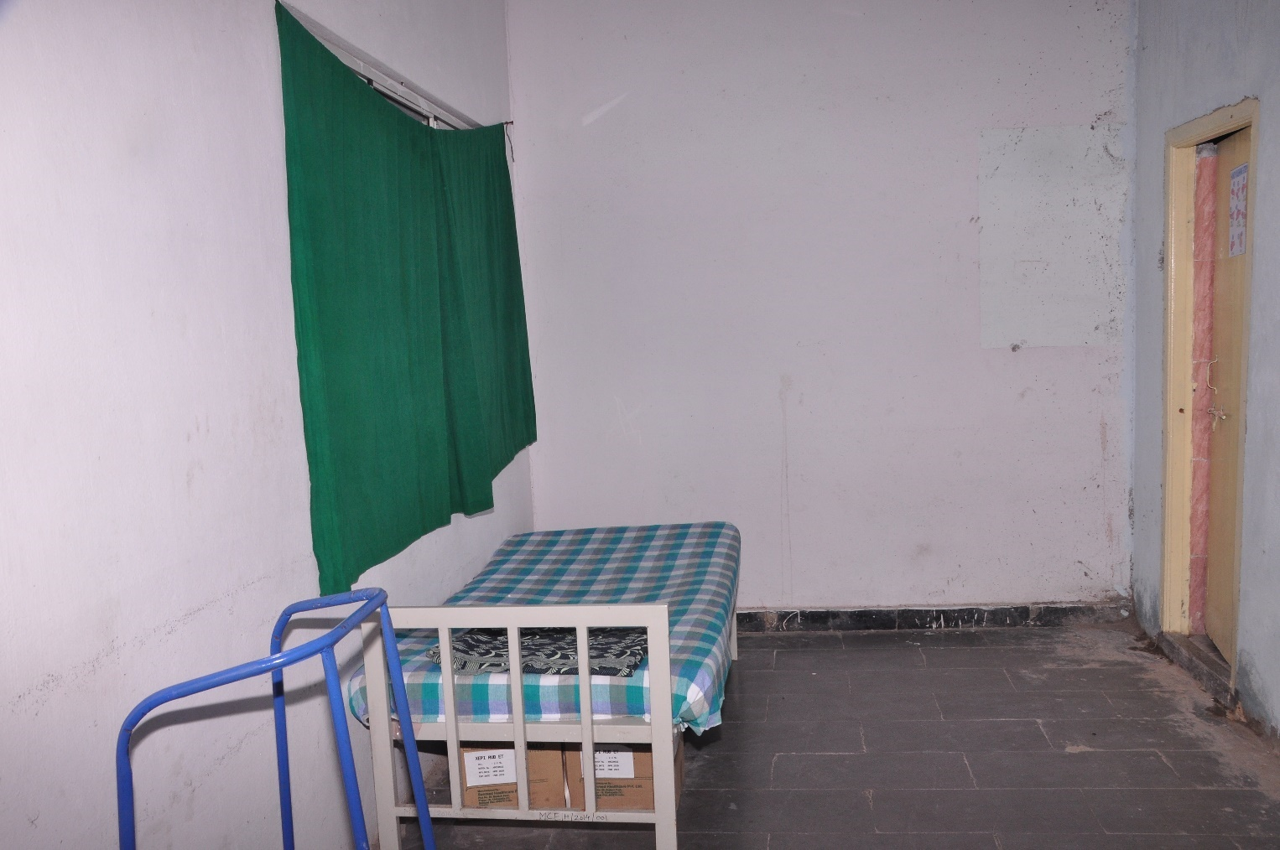
COVID Isolation centre
We are glad to submit our annual report with many positive ailments even in this covid pandemic.
- Admissions 2020-2021 completed without single casualty.
- AFCAT & CDS 2020 crash course completed without any casualty and 4 cadets cleared, 3 got cadets selected for Airforce.
- Finished semester examinations without covid cases in this pandemic.
- 50% chronic severe anaemic cases improved with iron rich diet and medication.
- Less number of general health issues reported and got treated with in wellness centre.
- Gynaec consultations arranged and improvement is seen in most of the cases reported.

Detailed report is given below:
Admissions 2020-2021
To start with we took all necessary measures like thermal screening of candidates and their parents, sodium hypo chloride spray regularly in campus with support of Grampanchayath, provided masks, gloves, sanitizers and hand wash to avoid spread of covid during our admissions 2020-2021 and could finish our task without any casualty.
Observations in medical screening are as following
Day | Total Candidates | Fit | Unfit | Refractive Error | Others
1 | 11 | 5 | 6 | 5 | Elbow Bend- 1
2 | 23 | 7 | 16 | 14 | Knock Knees- 1, Flat foot- 1
3 | 19 | 8 | 11 | 9 | Knock Knees- 2
4 | 25 | 12 | 13 | 11 | Height- 1, Knock Knees- 1
5 | 33 | 16 | 17 | 13 | Height- 1, Elbow Bend- 2, Knock Knees- 1
6 | 23 | 13 | 10 | 8 | Elbow Bend- 2
7 | 37 | 15 | 22 | 18 | Elbow Bend- 2, Knock Knees- 1
8 | 56 | 27 | 29 | 25 | Knock Knees- 2, Flat Foot- 1, Elbow Bend- 1
9 | 41 | 24 | 17 | 8 | Knock Knees- 1, Flat Foot- 3, Elbow Bend- 1, Surgery- 2
10 | 48 | 24 | 24 | 14 | Elbow Bend- 6, Kock Knees- 3, Flat Foot- 1
11 | 60 | 29 | 31 | 25 | Flat Foot- 2, Elbow Bend- 1, Knock Knees- 3
12 | 18 | 2 | 6 | 5 | Knock Knees- 1
13 | 3 | 22 | 1 | 1
14 | 22 | 2 | 10 | 8 | Height- 1, Elbow Bend- 1
15 | 17 | 11 | 6 | 4 | E.B-1,K.K-1
16 | 8 | 4 | 4 | 4 | -
17 | 3 | 1 | 2 | 2 | E.B-1
18 | 11 | 6 | 5 | 5 | -
19 | 4 | 1 | 3 | 1 | -
20 | 1 | 1 | - | - | -
21 | 42 | 21 | 21 | 15 | F.F- 3, K.K- 9, E.B- 2
22 | 84 | 53 | 31 | 21 | F.F- 5, K.K- 7, E.B- 1
23 | 74 | 31 | 43 | 17 | F.F- 5, K.K- 3, E.B- 3,
24 | 41 | 18 | 23 | 11 | E.B- 4, F.F- 1, K.K- 1
Total | 704 | 353 | 351 | 244

Measures taken during AFCAT training & Examinations :
Students with covid report are only allowed.
Regular Counselling of students was done to wear mask, maintain physical distance,
Use sanitize, take steam inhalation, and maintain personal hygiene.
Inhouse Isolation center arranged.
Rapid Antigen Tests are done for all students and staff twice after the reopening of college for examinations with the help of DM& HO, Bhongir.
Only 1 girl tested +ve whose recovery was uneventful at college isolation center. Twice RATs were performed with the help of Panacea.
Details are as follows:
Date | RAT performed by | Total students screened | Remarks
7-10-2020 | DM&HO, BHONGIR | 270 | Covid +ve – 1
19-11-2020 | ITMR | 22 | COVID – NILL
28-1-2021 | ITMR | 12 | COVID – NILL

Sick student’s data:
Total reported: 680
General: 563[ 536 cases treated inhouse, 24- visited hospital for investigation and management]
Emergency: 13
Severe Anaemia:1
Renal colic: 3
Acute OME: 1
Appendicitis: 2
Covid cases: 6[ 1 under home isolation]
Chronic: 104
Anaemia: 96- cured-52, under treatment:44
Renal calculi:2 - under treatment – size of the calculus reduced
Renal colic:1-cured
Taenia : 1- improved with medication
Bronchitis: 2 – no frequent sob, improved
ENT:2- CSOM- cured, hearing impairment-1- using aid
Admitted cases: 2
DATE | NAME | IAGNOSIS | HOSPITAL | TREATMENT
11-3-2020 | A.Balapriya | Appendicitis | RIMS | Appendectomy
15-9-2020 | T.Rishitha | Appendicitis | KAMINENI | Appendectomy

Underwent surgery:3
Date | Name | Diagnosis | Surgery performed | Condition
12-3-2020 | - Balapriya | Appendicitis | Appendectomy | Stable
15-9-2020 | T.Rishitha | Appendicitis | Appendectomy | Stable
26-2-2021 | G.Chamundeswari devi | Refractive error | LASIK -FEMTOSECOND | Stable

Gynaecologist consultations:
Date | Doctor visited | No of students examined | Remarks
14-3-2020 | Dr. Prashanthi | 22 | 11-irregular cycles. White discharge-4.menorrhagea-2. PCOS-2. Scanty menstruation-2.breast tenderness-1
15-3-2021 | Dr. Dakshayani | 50 | 20-irregula cycles. white discharge-9-cured. Menorrhagea: 5- cured. PCOS-3-under medication – getting regular cycles. Scanty menstruation- feeling better now.
LSG meetings:
Sick leaders are trained to resuscitate in emergency.
Meetings conducted regularly to avoid delay in management of sick students and monthly to address any other issues including Principal, Health supervisor, house parents, sick leaders and ACT
Regular skits are performed by students to create awareness among students. Students are educated about health and hygiene on healthy Tuesdays.
Anaemic cases are given special diet regularly in the supervision of concerned sick leaders.
Donation: Sowbal Aerothermics ltd has donated incinerator for cadets which is fixed inside the campus.
Last but not least:
We could send our cadets safe to SSB interview with all protective measures at college in this pandemic.
We could have very less no of covid positive cases recovered uneventful with regular follow up and regular counselling of parents and cadets regarding covid protocol and preventive measures.
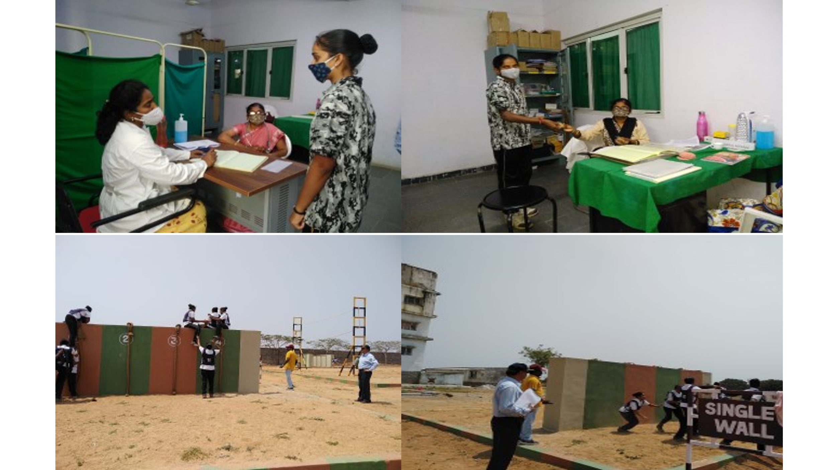

17-19 february' 2023 -Mask making-Distributionto inhouse students and staff workshop was conducted .
Students attended -25.
Students were educated by Dr.N.Saroja about the use of wearing in prevention of multiple ailments. Stucture of a mask for better prevention is designed (double layered model with tags to tie in four edges )
Stitching machines were landed from faculty.
Total no.of 1100 masks were prepared.
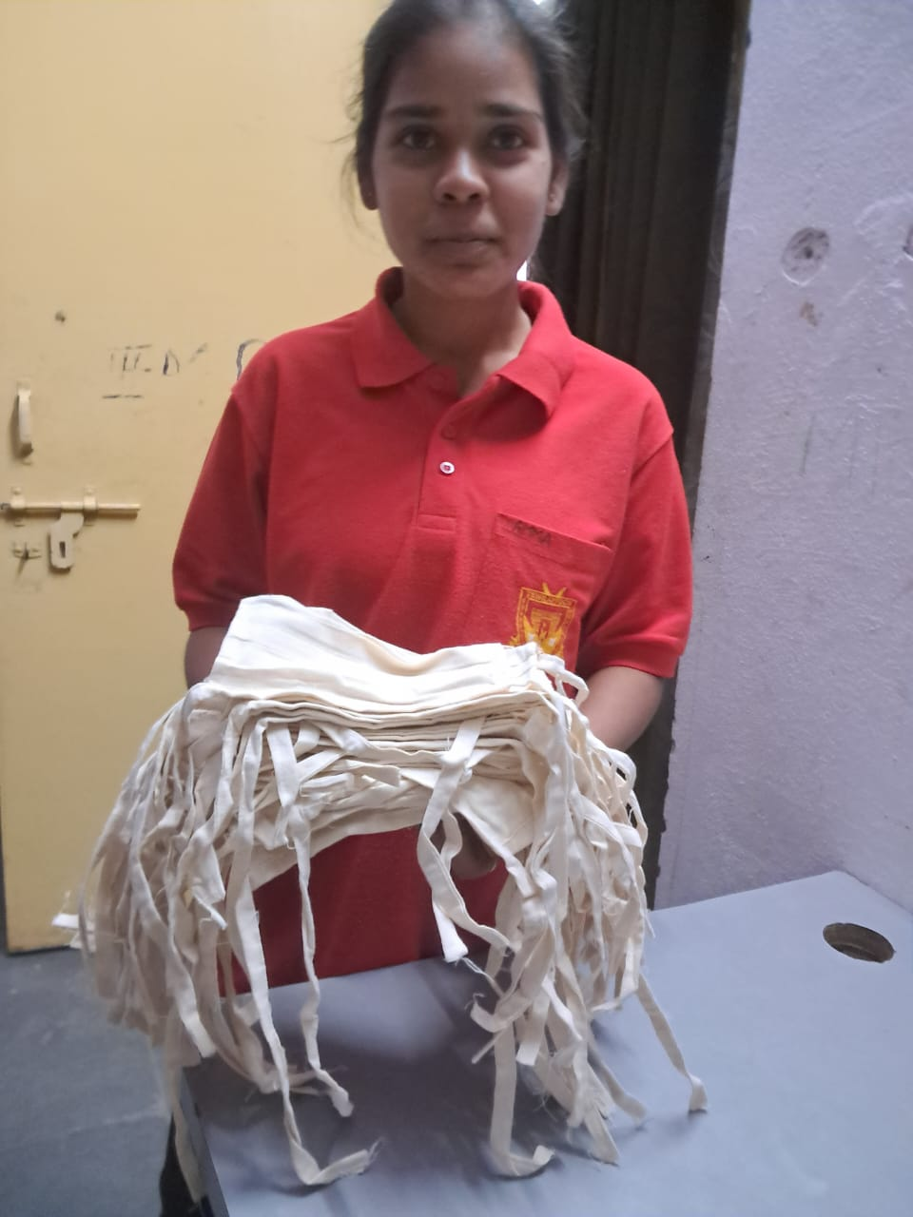

WORLD ANAEMIA DAY
March 21st
Conducted counselling session for anemic students to educate about the importance of diet in anemia and complications of anemia.Iron folic acid ,chikki distribution was done .
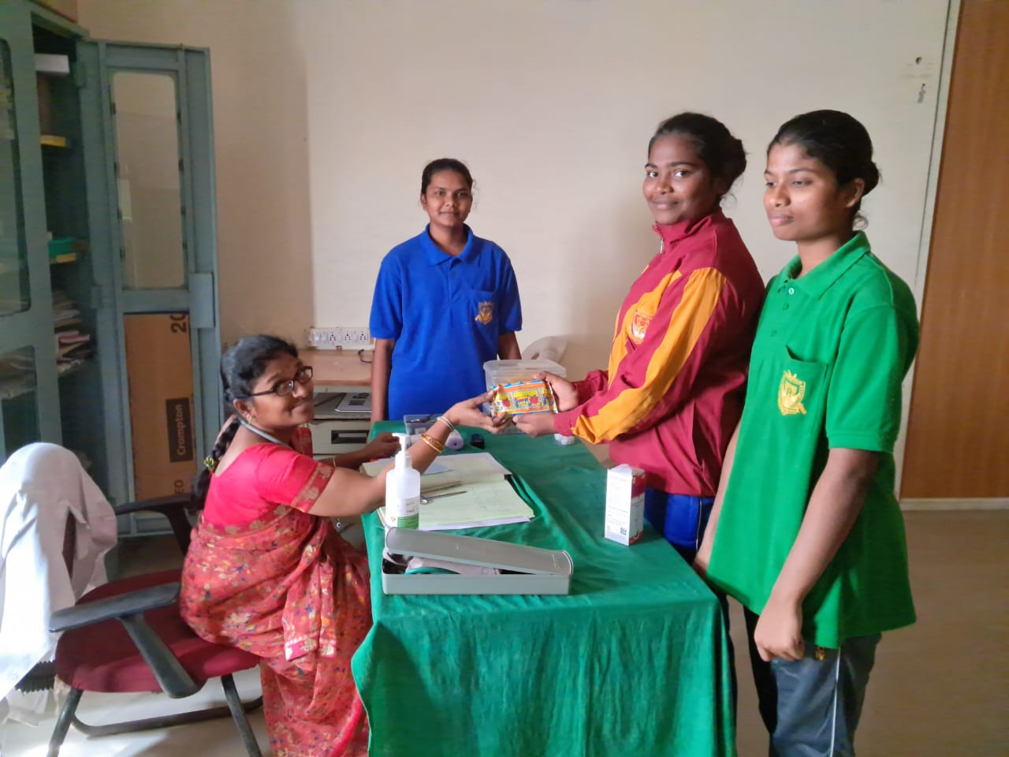

ANEMIA SCREENING PROGRAM
Conducted by – Dr.N.Saroja,PHC team,Panacea on 30-1-2019
Total 279 students were screened with the help of Sahli’s method among which 113 were mild anemic and 2 were moderately anemic.Neccesary treatment was given .
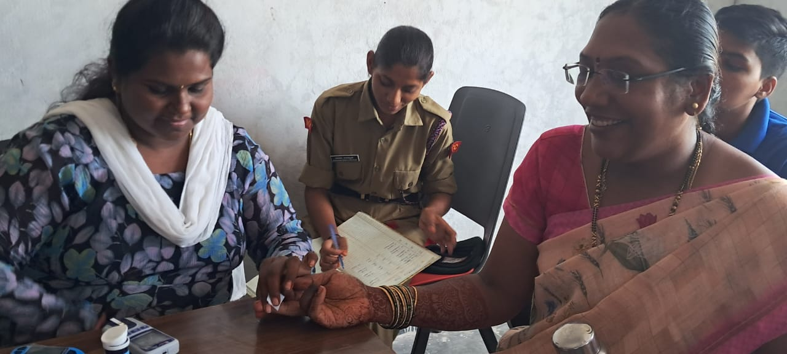

18-8-2019 Hb screening camp conducted with the help of Phc team by Dr.N.Saroja -almost 50% anemic students impoved.

WORLD MENSTRUAL HYGIENE DAY,28-05-2019
Dr.N.Saroja our health supervisor educated students about menstrual hygiene and its importance. Proper disposal methods of sanitary napkins explained. Usage of menstrual cups also shown.
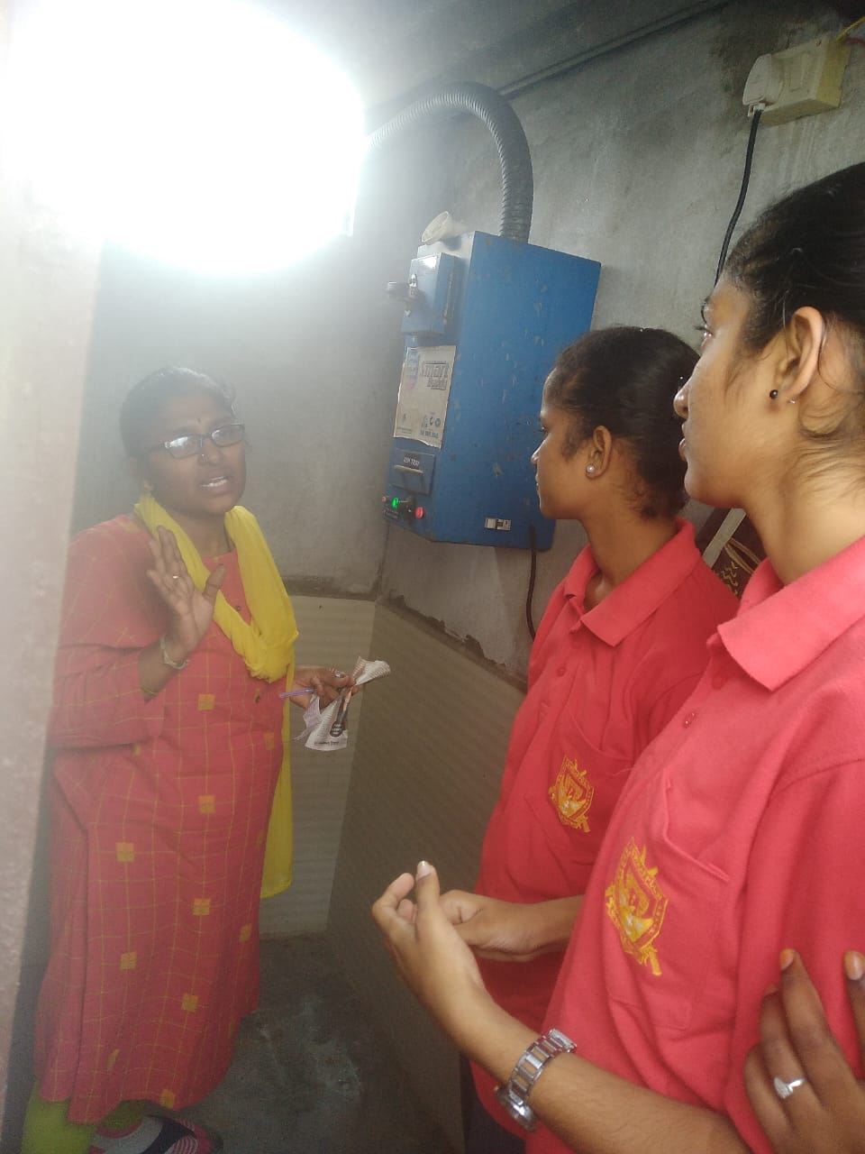

National vaccination day
March 16th 2023
Students were enlightened by Dr.N.Saroja about the role of vaccines in prevention and management . Educated about the false believes on disadvantages of vaccines by skit performance.
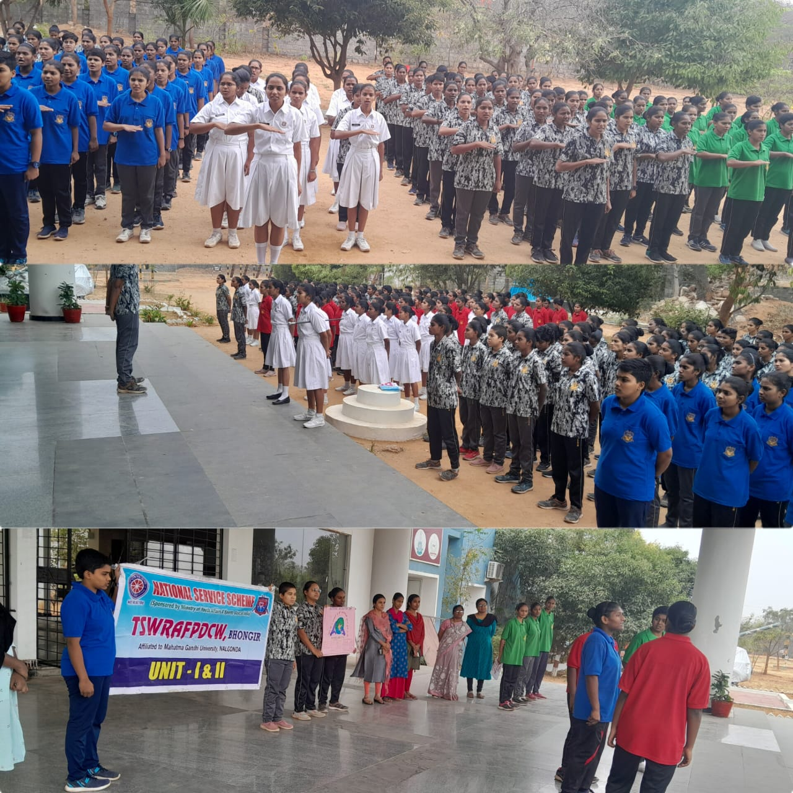

Aarogya dinotsavam
As part of dashaabdi utsavaas
15-06-2023
Detailed knowledge about all government health programmes was given by our resident doctor Dr.N.Saroja . Hb and RBS camp was conducted with the help of PHC team .
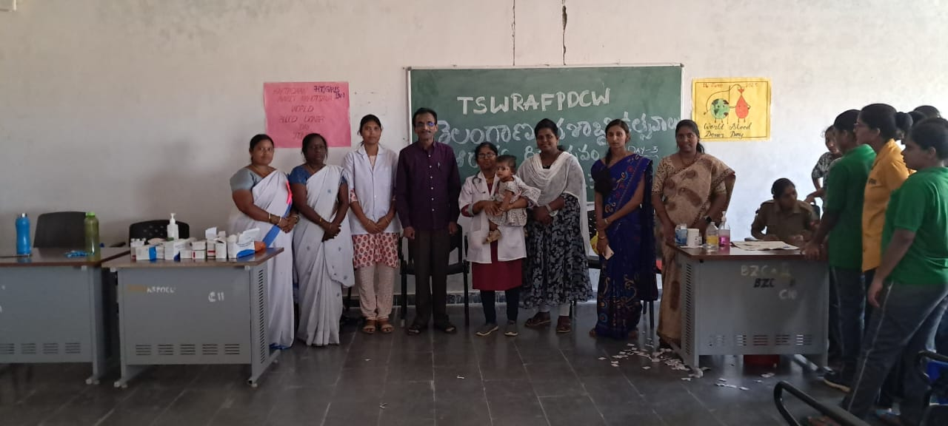
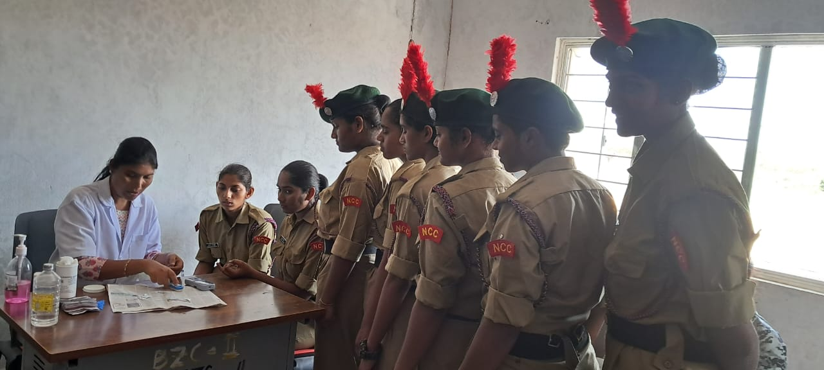

INTERNATIONAL YOGA DAY
21-06-23
9th International yoga day was celebrated grandly at Tharani hall by Dr.N.Saroja with the help of PHC doctor Dr.Sharmila and Mr.Karthik, yoga trainer international yoga centre,Gacchibowli.
Dr.N.Saroja explained the origin and parts of yoga i.e ashtanga yoga
Mr.Karthik- shown different yogasanas and explained their role in emergency management and health benefits.
Students also participated actively by performing different formations in yogasanas.
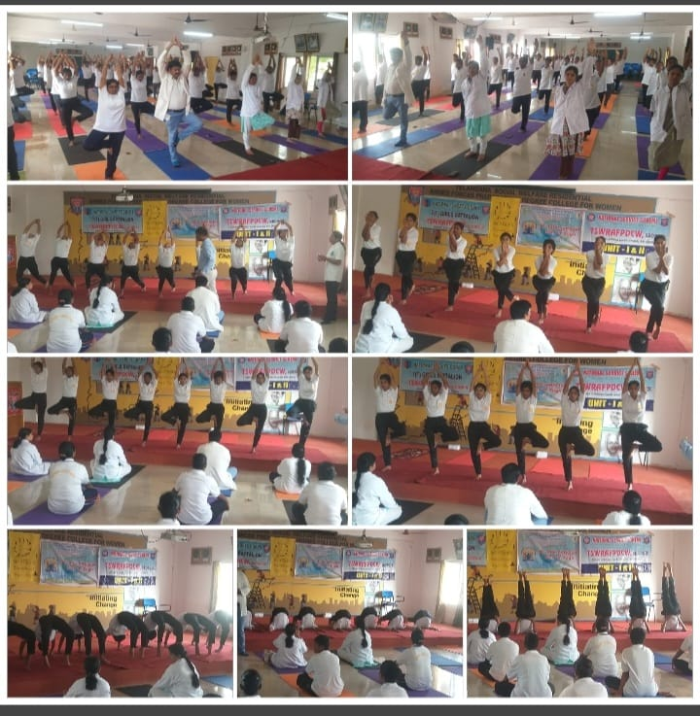
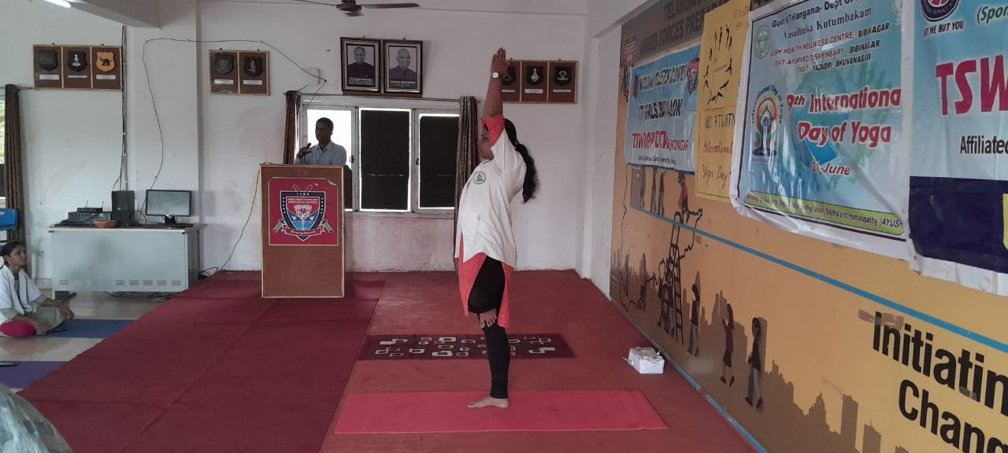
Awareness Programme on Communicable Disease Prevention
3-07-23
In view of continuous rain fall Dr. N.Saroja conducted counselling session on communicable disease prevention and role of hygiene in prevention with the help of Dr.Sushma ,wellness centre , Raghavapuram.
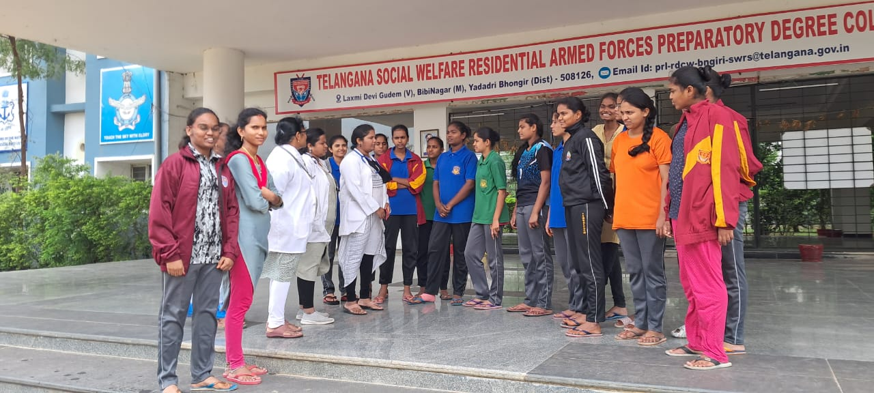
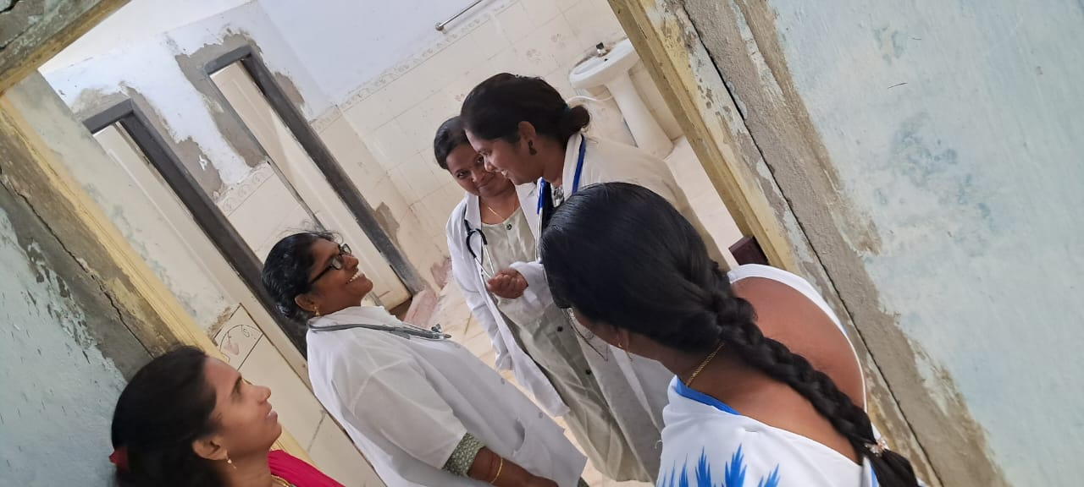

National Deworming Day
3-08-23
Importance deworming , prevention of worm infestation and its complications were explained to students by Dr.N.Saroja. albendazole supplement distribution was done with the help of PHC team, Bibinagar.
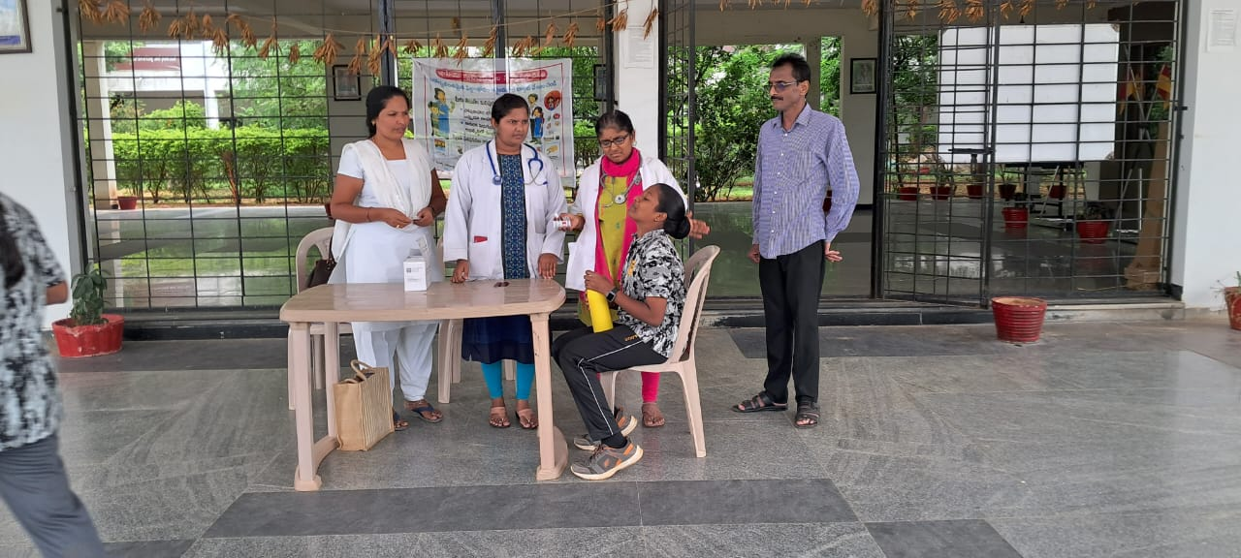
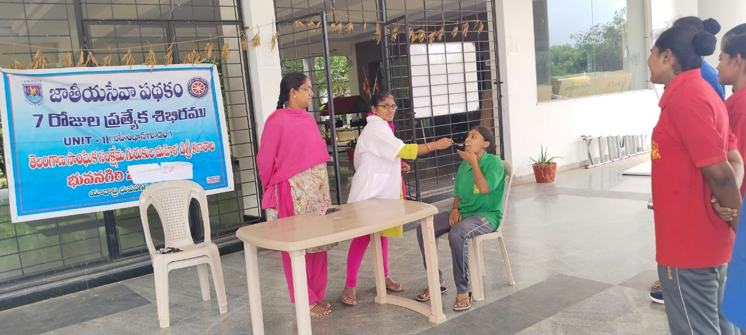
ROLE OF GENE ENGINEERINGING IN WOMEN HEALTH
19-08-23
TSWRS[G],JC students were educated about gene structure and importance of gene engineering in women health and management of genetic disorders and other chronic diseases by Dr.N.Saroja.
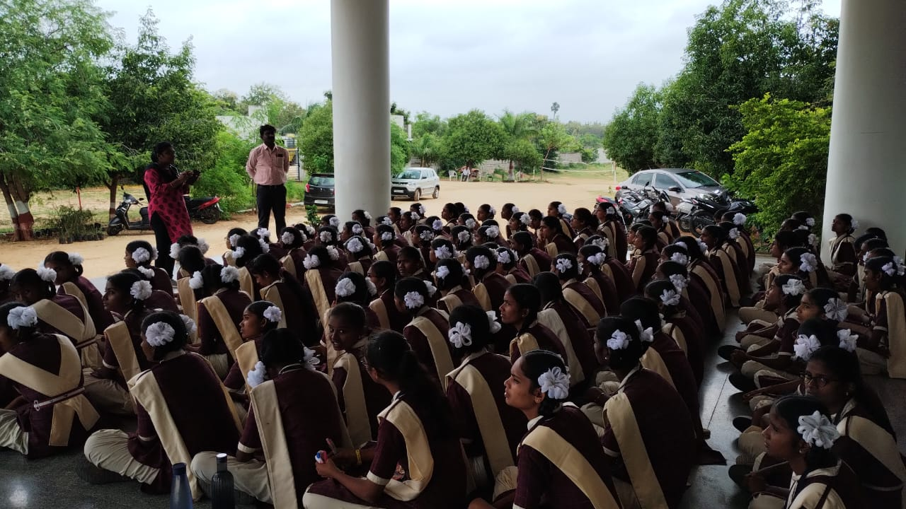

Awareness Programme on PMJAY Aarogyasree policy
29-08-23
With the help of arogyasree team Mrs. Sharada, Dr.N.Saroja educated students about new collaboration of PMJAY policy with Aarogyasree and its benefits in getting costly procedures to poor people , its registration process also explained so that the information will reach each and every home.
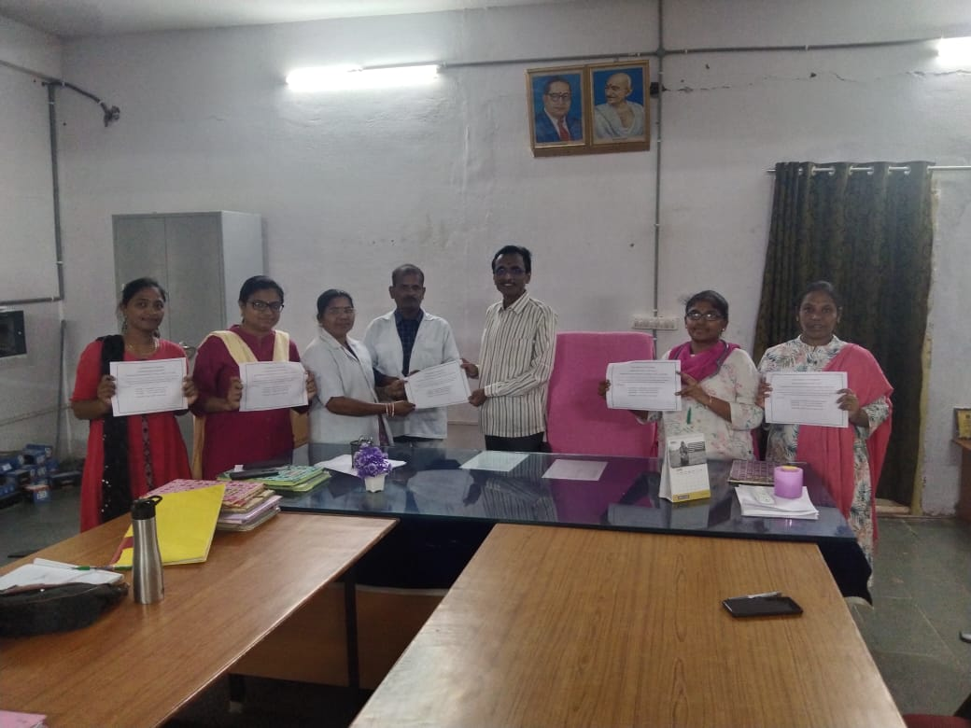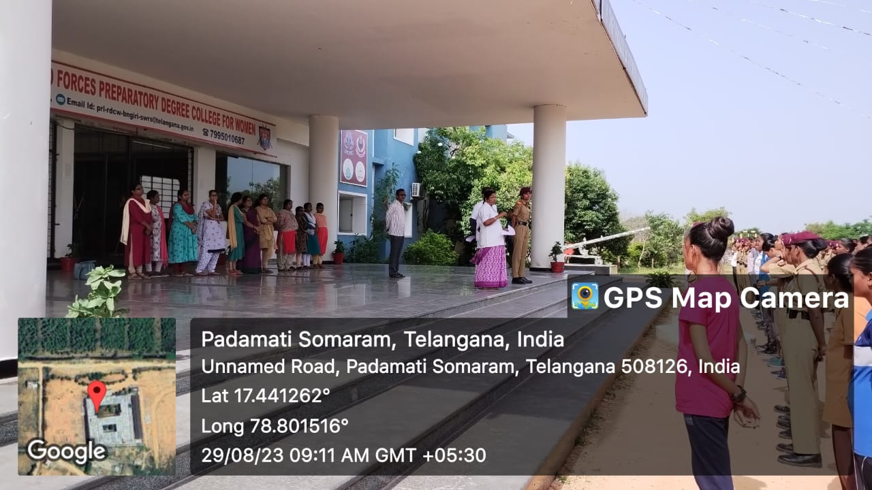
List of Activities conducted by Health and Hygiene Department
2018 | https://rdcwbhongir.tswreis.ac.in/Docs/list%20of%202018.pdf
2019 | https://rdcwbhongir.tswreis.ac.in/Docs/list%20of%202019.pdf
2020 | https://rdcwbhongir.tswreis.ac.in/Docs/list%20of%202020.pdf
2021 | https://rdcwbhongir.tswreis.ac.in/Docs/list%20of%202021.pdf
2022 | https://rdcwbhongir.tswreis.ac.in/Docs/list%20of%202022.pdf
2023 | https://rdcwbhongir.tswreis.ac.in/Docs/list%20of%202023.pdf
2024 | https://rdcwbhongir.tswreis.ac.in/Docs/list%20of%202024.pdf

